**1.** **R AS CALCULATOR APPLICATION**

**(i) Without using R objects on console**

> 25+32

Output:

[1] 57

> 36-15

Output:

[1] 21

> 145*8

[1] 1160

> 365/7

Output:

[1] 52.14

**(ii) Using R objects on console:**

>A=45

>B=2

>c=A+B

>c

Output:

[1]47

>A=5

>B=2

>c=A-B

>c

Output:

[1]3

>A=10

>B=2

>c=A*B

>c

Output:

[1]20

>A=4

>B=2

>c=A/B

>c

Output:

[1]2

**(c) Program make a simple calculator that can add, subtract, multiply and divide using functions**

add <- function(x, y) {

return(x + y)

}

subtract <- function(x, y) {

return(x - y)

}

multiply <- function(x, y) {

return(x * y)

}

divide <- function(x, y) {

return(x / y)

}

# take input from the user

print("Select operation.")

print("1.Add")

print("2.Subtract")

print("3.Multiply")

print("4.Divide")

choice = as.integer(readline(prompt="Enter choice[1/2/3/4]: "))

num1 = as.integer(readline(prompt="Enter first number: "))

num2 = as.integer(readline(prompt="Enter second number: "))

operator <- switch(choice,"+","-","*","/")

result <- switch(choice, add(num1, num2), subtract(num1, num2), multiply(num1, num2), divide(num1, num2))

print(paste(num1, operator, num2, "=", result))

**OUTPUT**

> source("~/Documents/305.R")

[1] "Select operation."

[1] "1.Add"

[1] "2.Subtract"

[1] "3.Multiply"

[1] "4.Divide"

Enter choice[1/2/3/4]: 3

Enter first number: 3

Enter second number: 4

[1] "3 * 4 = 12"

**2.DESCRIPTIVE STATISTICS IN R**

a. Write an R script to find basic descriptive statistics using summary, str, quartile function on mtcars& cars datasets.

load data mtcars:

data(mtcars)

structure of mtcars:

str(mtcars)

Output:

## 'data.frame': 32 obs. of 11 variables:

## $ mpg : num 21 21 22.8 21.4 18.7 18.1 14.3 24.4 22.8 19.2 ...

## $ cyl : num 6 6 4 6 8 6 8 4 4 6 ...

## $ disp: num 160 160 108 258 360 ...

## $ hp : num 110 110 93 110 175 105 245 62 95 123 ...

## $ drat: num 3.9 3.9 3.85 3.08 3.15 2.76 3.21 3.69 3.92 3.92 ...

## $ wt : num 2.62 2.88 2.32 3.21 3.44 ...

## $ qsec: num 16.5 17 18.6 19.4 17 ...

## $ vs : num 0 0 1 1 0 1 0 1 1 1 ...

## $ am : num 1 1 1 0 0 0 0 0 0 0 ...

## $ gear: num 4 4 4 3 3 3 3 4 4 4 ...

## $ carb: num 4 4 1 1 2 1 4 2 2 4 ...

str( ) 🡪 This function compactly displays the internal structure of an R object, a diagnostic function and an alternative to summary. Ideally, only one line for each ‘basic’ structure is displayed. It is especially well suited to compactly display the (abbreviated) contents of (possibly nested) lists.

dimension of dataset:

dim(mtcars)

Output:

[1] 32 11

get names of each variables or columns:

names(mtcars)

Output:

[1] "mpg" "cyl" "disp" "hp" "drat" "wt" "qsec" "vs" "am" "gear" "carb"

Summaries of the datasets:

summary( )🡪 is a generic function used to produce summaries of the results of various model fitting functions. The function invokes particular methods which depend on the class of the first argument.

**Usage:**

>summary(mtcars)

Output:

mpg cyl disp hp drat

Min. :10.40 Min. :4.000 Min. : 71.1 Min. : 52.0 Min. :2.760

1st Qu.:15.43 1st Qu.:4.000 1st Qu.:120.8 1st Qu.: 96.5 1st Qu.:3.080

Median :19.20 Median :6.000 Median :196.3 Median :123.0 Median :3.695

Mean :20.09 Mean :6.188 Mean :230.7 Mean :146.7 Mean :3.597

3rd Qu.:22.80 3rd Qu.:8.000 3rd Qu.:326.0 3rd Qu.:180.0 3rd Qu.:3.920

Max. :33.90 Max. :8.000 Max. :472.0 Max. :335.0 Max. :4.930

wt qsec vs am gear

Min. :1.513 Min. :14.50 Min. :0.0000 Min. :0.0000 Min. :3.000

1st Qu.:2.581 1st Qu.:16.89 1st Qu.:0.0000 1st Qu.:0.0000 1st Qu.:3.000

Median :3.325 Median :17.71 Median :0.0000 Median :0.0000 Median :4.000

Mean :3.217 Mean :17.85 Mean :0.4375 Mean :0.4062 Mean :3.688

3rd Qu.:3.610 3rd Qu.:18.90 3rd Qu.:1.0000 3rd Qu.:1.0000 3rd Qu.:4.000

Max. :5.424 Max. :22.90 Max. :1.0000 Max. :1.0000 Max. :5.000

carb

Min. :1.000

1st Qu.:2.000

Median :2.000

Mean :2.812

3rd Qu.:4.000

Max. :8.000

quantiles of dataset:

quantile()

The generic function quantile produces sample quantiles corresponding to the given probabilities. The smallest observation corresponds to a probability of 0 and the largest to a probability of 1.

Common quantiles have special names, such as quartiles (four groups), deciles (ten groups), and percentiles (100 groups). The groups created are termed halves, thirds, quarters, etc., though sometimes the terms for the quantile are used for the groups created, rather than for the cut points.

Ex:

x=1:10

> x

Output:

[1] 1 2 3 4 5 6 7 8 9 10

> quantile(x)

Output:

0% 25% 50% 75% 100%

1.00 3.25 5.50 7.75 10.00

> quantile(mtcars$mpg)

Output:

0% 25% 50% 75% 100%

10.400 15.425 19.200 22.800 33.900

select quantiles by percent

quantile(mtcars$wt, c(.2, .4, .8))

Output:

20% 40% 80%

2.349 3.158 3.770

variance

variance of weight:

var(mtcars$wt)

Output:

[1] 0.957379

Covariance

get covariance between mpg and gear:

cov(mtcars$mpg, mtcars$gear)

Output:

[1] 2.135685

get covariance all variables:

cov(mtcars[,1:11])

Output:

mpg cyl disp hp drat

## mpg 36.324103 -9.1723790 -633.09721 -320.732056 2.19506351

## cyl -9.172379 3.1895161 199.66028 101.931452 -0.66836694

## disp -633.097208 199.6602823 15360.79983 6721.158669 -47.06401915

## hp -320.732056 101.9314516 6721.15867 4700.866935 -16.45110887

## drat 2.195064 -0.6683669 -47.06402 -16.451109 0.28588135

## wt -5.116685 1.3673710 107.68420 44.192661 -0.37272073

## qsec 4.509149 -1.8868548 -96.05168 -86.770081 0.08714073

## vs 2.017137 -0.7298387 -44.37762 -24.987903 0.11864919

## am 1.803931 -0.4657258 -36.56401 -8.320565 0.19015121

## gear 2.135685 -0.6491935 -50.80262 -6.358871 0.27598790

## carb -5.363105 1.5201613 79.06875 83.036290 -0.07840726

## wt qsec vs am gear

## mpg -5.1166847 4.50914919 2.01713710 1.80393145 2.1356855

## cyl 1.3673710 -1.88685484 -0.72983871 -0.46572581 -0.6491935

## disp 107.6842040 -96.05168145 -44.37762097 -36.56401210 -50.8026210

## hp 44.1926613 -86.77008065 -24.98790323 -8.32056452 -6.3588710

## drat -0.3727207 0.08714073 0.11864919 0.19015121 0.2759879

## wt 0.9573790 -0.30548161 -0.27366129 -0.33810484 -0.4210806

## qsec -0.3054816 3.19316613 0.67056452 -0.20495968 -0.2804032

## vs -0.2736613 0.67056452 0.25403226 0.04233871 0.0766129

## am -0.3381048 -0.20495968 0.04233871 0.24899194 0.2923387

## gear -0.4210806 -0.28040323 0.07661290 0.29233871 0.5443548

## carb 0.6757903 -1.89411290 -0.46370968 0.04637097 0.3266129

## carb

## mpg -5.36310484

## cyl 1.52016129

## disp 79.06875000

## hp 83.03629032

## drat -0.07840726

## wt 0.67579032

## qsec -1.89411290

## vs -0.46370968

## am 0.04637097

## gear 0.32661290

## carb 2.60887097

Correlation

get correlation between mpg and gear:

cor(mtcars$mpg, mtcars$gear)

Output:

[1] 0.4802848

get correlation all variables:

cor(mtcars[,1:11])

Output:

mpg cyl disp hp drat wt

## mpg 1.0000000 -0.8521620 -0.8475514 -0.7761684 0.68117191 -0.8676594

## cyl -0.8521620 1.0000000 0.9020329 0.8324475 -0.69993811 0.7824958

## disp -0.8475514 0.9020329 1.0000000 0.7909486 -0.71021393 0.8879799

## hp -0.7761684 0.8324475 0.7909486 1.0000000 -0.44875912 0.6587479

## drat 0.6811719 -0.6999381 -0.7102139 -0.4487591 1.00000000 -0.7124406

## wt -0.8676594 0.7824958 0.8879799 0.6587479 -0.71244065 1.0000000

## qsec 0.4186840 -0.5912421 -0.4336979 -0.7082234 0.09120476 -0.1747159

## vs 0.6640389 -0.8108118 -0.7104159 -0.7230967 0.44027846 -0.5549157

## am 0.5998324 -0.5226070 -0.5912270 -0.2432043 0.71271113 -0.6924953

## gear 0.4802848 -0.4926866 -0.5555692 -0.1257043 0.69961013 -0.5832870

## carb -0.5509251 0.5269883 0.3949769 0.7498125 -0.09078980 0.4276059

## qsec vs am gear carb

## mpg 0.41868403 0.6640389 0.59983243 0.4802848 -0.55092507

## cyl -0.59124207 -0.8108118 -0.52260705 -0.4926866 0.52698829

## disp -0.43369788 -0.7104159 -0.59122704 -0.5555692 0.39497686

## hp -0.70822339 -0.7230967 -0.24320426 -0.1257043 0.74981247

## drat 0.09120476 0.4402785 0.71271113 0.6996101 -0.09078980

## wt -0.17471588 -0.5549157 -0.69249526 -0.5832870 0.42760594

## qsec 1.00000000 0.7445354 -0.22986086 -0.2126822 -0.65624923

## vs 0.74453544 1.0000000 0.16834512 0.2060233 -0.56960714

## am -0.22986086 0.1683451 1.00000000 0.7940588 0.05753435

## gear -0.21268223 0.2060233 0.79405876 1.0000000 0.27407284

## carb -0.65624923 -0.5696071 0.05753435 0.2740728 1.00000000

**b. Write an R script to find subset of dataset by using subset (), aggregate () functions on iris dataset.**

Subset

It return subsets of vectors, matrices or data frames meeting given conditions.

>subset(iris,iris$Sepal.Length>7)

Output:

Sepal.Length Sepal.Width Petal.Length Petal.Width Species

103 7.1 3.0 5.9 2.1 virginica

106 7.6 3.0 6.6 2.1 virginica

108 7.3 2.9 6.3 1.8 virginica

110 7.2 3.6 6.1 2.5 virginica

118 7.7 3.8 6.7 2.2 virginica

119 7.7 2.6 6.9 2.3 virginica

123 7.7 2.8 6.7 2.0 virginica

126 7.2 3.2 6.0 1.8 virginica

130 7.2 3.0 5.8 1.6 virginica

131 7.4 2.8 6.1 1.9 virginica

132 7.9 3.8 6.4 2.0 virginica

136 7.7 3.0 6.1 2.3 virginica

aggregate ()

aggregate() Function in R Splits the data into subsets, computes summary statistics for each subsets and returns the result in a group by form. Aggregate function in R is similar to group by in SQL. Aggregate() function is useful in performing all the aggregate operations like sum,count,mean, minimum and Maximum.

It splits the data into subsets, computes summary statistics for each, and returns the result in a convenient form.

The most basic uses of aggregate involve base functions such as mean and sd. It is indeed one of the most common uses of aggregate to compare the mean or other properties of sample groups.

Aggregate() function in R applied on iris dataset:

Step1:

Load the dataset

data(iris)

Step 2:

Apply aggregate() to calculate mean, sum

agg_mean = aggregate(iris[,1:4], by=list(iris$Species),FUN=mean)

Step 3:

Display the result

agg_mean

Similarly use aggegate() function to calculate:

* Sum:

agg_sum = aggregate(iris[,1:4], by=list(iris$Species),FUN=sum)

standard deviation:

agg_sd = aggregate(iris[,1:4], by=list(iris$Species),FUN=sd)

* Min value

agg_min = aggregate(iris[,1:4], by=list(iris$Species),FUN=min)

* Max value

agg_max = aggregate(iris[,1:4], by=list(iris$Species),FUN=max)

**3. READING AND WRITING DIFFERENT TYPES OF DATASETS**

**a. Reading different types of data sets (.txt, .csv) from web and disk and writing in file in specific disk location.**

# Set current working directory.

setwd("/DH/rprog”)

#Read the file

data <- read.csv("input.csv")

print(data)

**b. Reading Excel data sheet in R.**

#Install xlsx Package

install.packages("xlsx")

# Read the file input.xlsx.

data <- read.xlsx("input.xlsx")

print(data)

**4.VISUALIZATIONS**

**Find the data distributions using box and scatter plot.**

Install.packages(“ggplot2”) Library(ggplot2)

Input <- mtcars[,c('mpg','cyl')] input

Boxplot(mpg ~ cyl, data = mtcars, xlab = "number of cylinders", ylab = "miles per gallon", main = "mileage data")

Dev.off()

## Output :-

mpg cyl

Mazda rx4 21.0 6

Mazda rx4 wag 21.0 6

Datsun 710 22.8 4

Hornet 4 drive 21.4 6

Hornet sportabout 18.7 8

Valiant 18.1 6

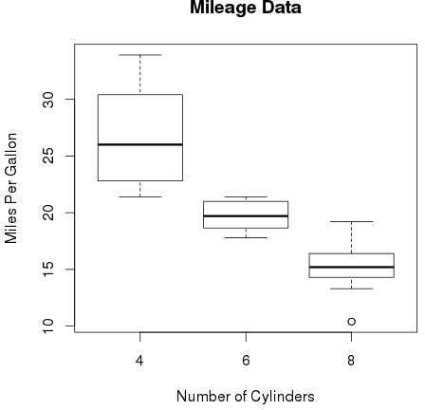

## Find the outliers using plot.

v=c(50,75,100,125,150,175,200)

boxplot(v)

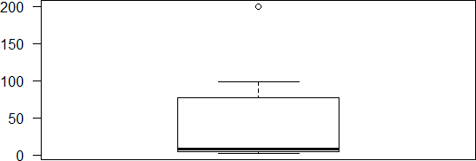

## Plot the histogram, bar chart and pie chart on sample data.

**Histogram**

library(graphics)

v <- c(9,13,21,8,36,22,12,41,31,33,19)

# Create the histogram.

hist(v,xlab = "Weight",col = "blue",border = "green") dev.off()

## Output:-

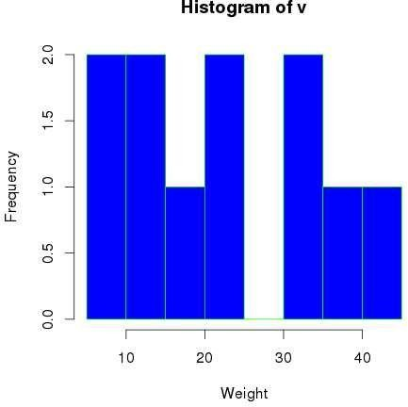

**Bar chart**

library(graphics)

H <- c(7,12,28,3,41)

M <- c("Jan","Feb","Mar","Apr","May") # Plot the bar chart.

barplot(H, names. arg = M, xlab = "Month", ylab = "Revenue", col = "blue", main = "Revenue chart")

dev.off()

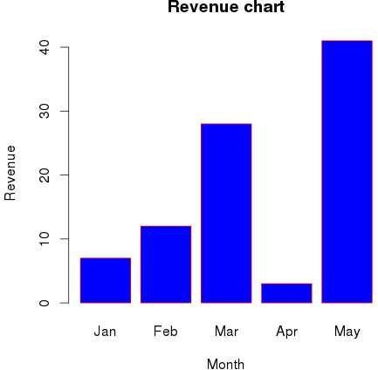

**Pie Chart**

library(graphics)

x <- c(21, 62, 10, 53)

labels<- c("London", "NewYork", "Singapore", "Mumbai") # Plot the Pie chart.

pie(x,labels) dev.off()

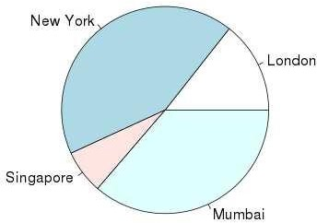

**5.CORRELATION AND COVARIANCE**

## Find the corelation matrix

d<-data.frame(x1=rnorm(!0),x2=rnorm(10),x3=rnorm(10)) cor(d)

m<-cor(d) #get correlations library(„corrplot‟) corrplot(m,method=”square”)

x<-matrix(rnorm(2),,nrow=5,ncol=4)

y<-matrix(rnorm(15),nrow=5,ncol=3)

COR<-cor(x,y)

COR

* + 1. Plot the correlation plot on dataset and visualize giving an overview of relationships among data on iris data.

Image(x=seq(dim(x)[2])

Y<-seq(dim(y)[2]) Z=COR,xlab=”xcolumn”,ylab=”y column”) Library(gtlcharts)

Data(iris) Iris$species<-NULL

Iplotcorr(iris,reoder=TRUE)

* + 1. **Analysis of covariance: variance (**[**ANOVA**](http://personality-project.org/r/r.205.tutorial.html#anova)**), if data have categorical variables on iris data.** library(ggplot2) data(iris) str(iris)

ggplot(data=iris,aes(x=sepal.length,y=petal.length))+geom_point(size=2,colour=”black”)+geom_ point(size=1,colour=”white”)+geom_smooth(aes(colour=”black”),method=”lm‟)+ggtitle(“sepal.l engthvspetal.length”)+xlab(“sepal.length”)+ylab(“petal.length”)+these(legend.position=”none”)

## OUTPUT:

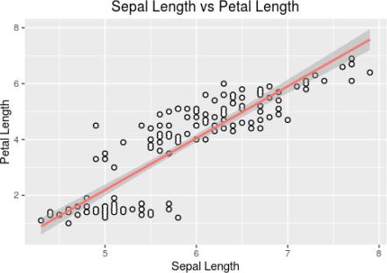

**6. REGRESSION MODEL**

Import a data from web storage. Name the dataset and perform Logistic Regression to find out relation between variables the model. Also check the model is fit or not [require (foreign), require(MASS)]

>mydata$rank<-factor(mydata$rank)

>mylogit<-glm(admit~gre+gpa+rank,data=mydata,family=”binomial”)

>summary(mylogit)

## OUTPUT:

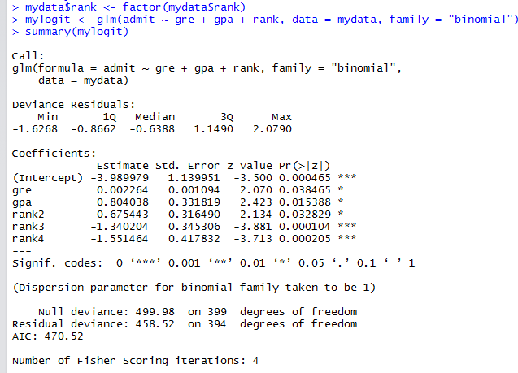

**7.CLASSIFICATION MODEL**

b. Choose classifier for classification problem.

**Classifier used: Decision Tree.**

The R package "party" is used to create decision trees.

Use the below command in R console to install the package. You also have to install the dependent packages if any.

install. packages("party")

The package "party" has the function ctree() which is used to create and analyze decison tree.

**Syntax**

The basic syntax for creating a decision tree in R is −

ctree(formula, data)

Here,

*formula* is a formula describing the predictor and response variables.

*data* is the name of the data set used.

**Input Data**

We will use the R in-built data set named readingSkills to create a decision tree. It describes the score of someone's readingSkills if we know the variables "age", "shoesize", "score" and whether the person is a native speaker or not.

Sample data from dataset readingSkills

|  |  |  |  |  |
| --- | --- | --- | --- | --- |
| **Sno** | **nativeSpeaker** | **age** | **shoeSize** | **score** |
| 1 | yes | 5 | 24.83189 | 32.29385 |
| 2 | yes | 6 | 25.95238 | 36.63105 |
| 3 | no | 11 | 30.42170 | 49.60593 |
| 4 | yes | 7 | 28.66450 | 40.28456 |
| 5 | yes | 11 | 31.88207 | 55.46085 |
| 6 | yes | 10 | 30.07843 | 52.83124 |

***Program:***

# Load the party package. It will automatically load other dependent packages.

library(party)

# Create the input data frame.

input.dat <- readingSkills[c(1:105),]

# Give the chart file a name.

png(file = "decision_tree.png")

# Create the tree.

output.tree <- ctree( nativeSpeaker ~ age + shoeSize + score, data = input.dat)

# Plot the tree.

plot(output.tree)

# Save the file.

dev.off()

**Output:**

null device

1

Loading required package: methods

Loading required package: grid

Loading required package: mvtnorm

Loading required package: modeltools

Loading required package: stats4

Loading required package: strucchange

Loading required package: zoo

Attaching package: ‘zoo’

The following objects are masked from ‘package:base’:

as.Date, as.Date.numeric

Loading required package: sandwich

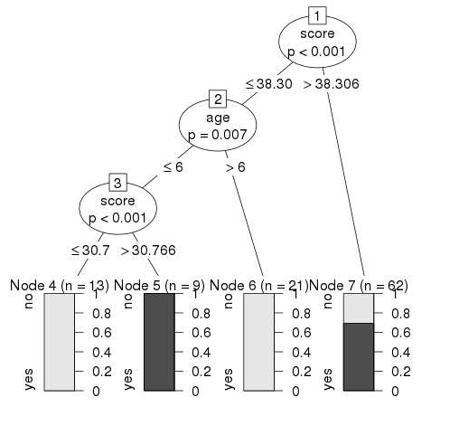

**8.CLUSTERING MODEL**

**a. Clustering algorithms for unsupervised classification.**

Using iris dataset and K-means Clustering algorithm

library(cluster)

* set.seed(20)
* irisCluster <- kmeans(iris[, 3:4], 3, nstart = 20)

# nstart = 20. This means that R will try 20 different random starting assignments and then select the one with the lowest within cluster variation.

* irisCluster

**output:**

Petal.Length Petal.Width 1 1.462000 0.246000

2 4.269231 1.342308

3 5.595833 2.037500

## Clustering vector:

[1] 1 1 1 1 1 1 1 1 1 1 1 1 1 1 1 1 1 1 1 1 1 1 1 1 1 1 1 1 1 1 1 1 1 1 1 1 1 1 1 1 1

[42] 1 1 1 1 1 1 1 1 1 2 2 2 2 2 2 2 2 2 2 2 2 2 2 2 2 2 2 2 2 2 2 2 2 2 2 2 3 2 2 2 2

[83] 2 3 2 2 2 2 2 2 2 2 2 2 2 2 2 2 2 2 3 3 3 3 3 3 2 3 3 3 3 3 3 3 3 3 3 3 3 2 3 3 3

[124] 3 3 3 2 3 3 3 3 3 3 3 3 3 3 3 2 3 3 3 3 3 3 3 3 3 3 3

## Within cluster sum of squares by cluster:

[1] 2.02200 13.05769 16.29167

(between_SS / total_SS = 94.3 %)

## Available components:

[1] "cluster" "centers" "totss" "withinss" "tot.withinss"

[6] "betweenss" "size" "iter" "ifault"

**b. Plot the cluster data using R visualizations**

* irisCluster$cluster <- as.factor(irisCluster$cluster)
* ggplot(iris, aes(Petal.Length, Petal.Width, color = irisCluster$cluster)) + geom_point()

## Output:

## 